- Leading survey indicators of household and corporate sentiment fell sharply this week, providing the first glimpses of how the conflict in the Middle East is hitting the UK economy. The flash S&P Global survey suggested that activity growth slowed sharply this month, amid weaker demand and rising input costs. Meanwhile, GfK's survey signalled a deterioration in consumer confidence.
- Speaking at events this week, four members of the Monetary Policy Committee largely confirmed our priors about how each member sees the monetary policy debate unfolding. But we continue to think that most committee members remain in 'wait and see' mode as they gather more information about how the energy shock is playing out.
It's been four weeks since the start of the US-Israel war with Iran, with significant volatility in financial and commodity markets remaining the dominant theme. There's still considerable uncertainty about how the conflict will evolve, given we've seen minimal tangible progress towards a sustainable ceasefire so far. But it's clear that the war will cause a protracted period of disruption to energy production in the Middle East and shipping through the Strait of Hormuz, which will have major implications for the UK economy.
This week's official UK economic releases contained data that preceded the outbreak of the conflict, providing little help to policymakers. The Office for National Statistics reported that CPI inflation held steady at 3% in February. The detail showed a further moderation in food, fuel, and services inflation before the start of the war. However, offsetting pressure came from the core goods category, which largely reflected the comparison with last year's unusually soft outturn in the clothing sub-category.
We expect CPI inflation to accelerate in the coming months as the impact of the conflict feeds through to the official data. We continue to assume that disruption in the Strait of Hormuz and damage to energy infrastructure will keep oil and gas prices high in Q2 before gradually dropping back. High frequency data shows that petrol prices have risen sharply during March, while the close relationship between Brent Crude and pump prices indicates further increases in the coming weeks are likely (Chart 1). Meanwhile, our gas price assumption is consistent with the Ofgem Energy Price Cap rising by 21% in July.
Chart 1: Brent Crude and petrol prices have risen sharply in recent weeks
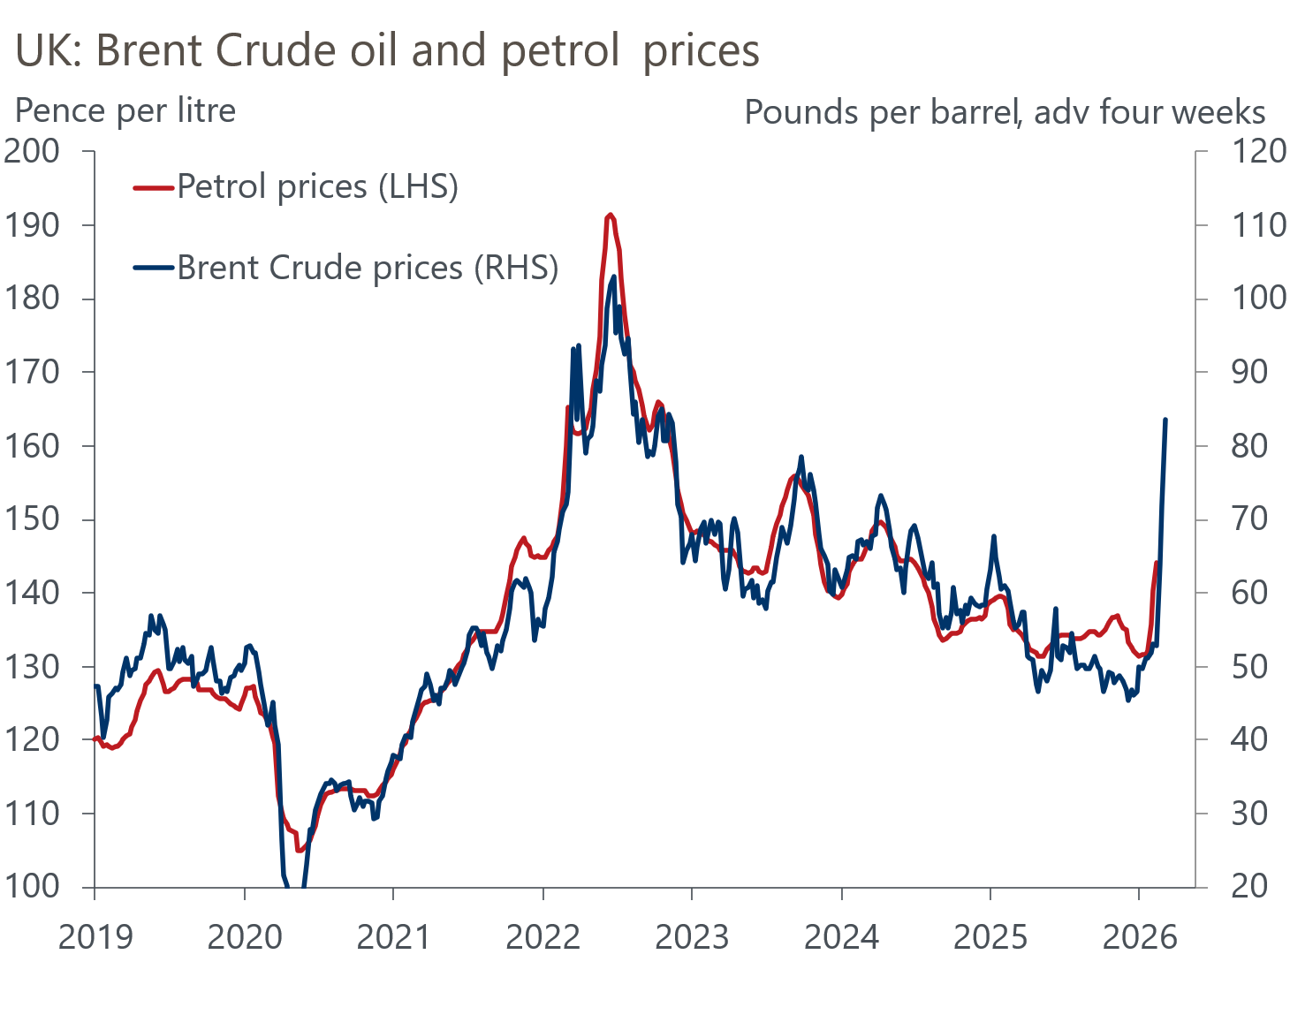
Sources: Oxford Economics, Department for Energy Security and Net Zero

We also anticipate some passthrough of higher fuel and energy costs for businesses to other parts of the inflation basket, such as food prices and the more energy-intensive parts of core inflation. However, we think second round effects via higher pay growth will be more limited than during the 2022-2023 episode, due to much looser labour market conditions and weak activity.
Following this week's data, our updated inflation forecast shows the CPI measure reaching 4.5% in H2 2026, and averaging 3.9% over 2026 as a whole. But strong base effects then drag inflation below the Bank of England's 2% target in H2 2027.
Surveys published this week provided the first glimpses of how the economic fallout from the ongoing conflict is shaping consumer and corporate sentiment. March's headline GfK consumer confidence index reported a fairly modest decline in sentiment. But the impact of the conflict was clearer in the survey's sub-indices, with the components measuring households' views on the general economic outlook and the likelihood they will make major purchases over the next 12 months falling sharply.
Elsewhere, March's flash S&P Global PMI survey reported a material slowdown in private sector activity growth. The composite PMI fell to 51.0 in March, from 53.7 in February, remaining barely above the 50 'no-change' mark and much weaker than its long-run trend (Chart 2).
Chart 2: The composite PMI slumped in March
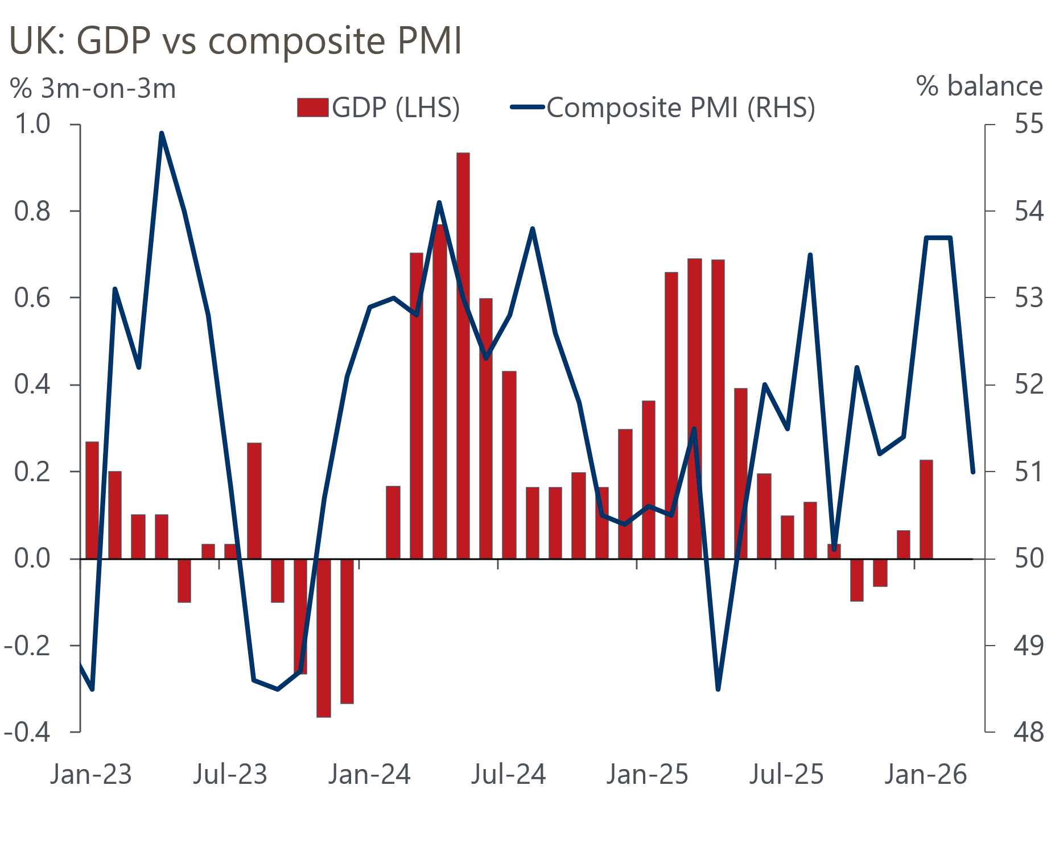
Sources: ONS, S&P Global
Respondents to the S&P Global survey also signalled that higher fuel and energy prices had led to the largest monthly increase in input costs since the Russia-Ukraine energy crisis. Firms don't appear to have fully reflected the spike in cost pressures in output prices yet, though it's clear that this is a dynamic that members of the BoE's Monetary Policy Committee will be watching very closely as they attempt to gauge how large and persistent any indirect and second-round effects of higher energy prices will be on the broader inflation basket.
The degree to which the energy shock feeds through to other prices will partly depend on how well anchored inflation expectations remain. We suspect the MPC will be concerned about the result of March's Citi/YouGov survey of inflation expectations, which reported that its measures of short- and long-term household inflation expectations surged after the outbreak of the war in the Middle East.
Following last week's MPC meeting, four committee members shed further light on how they view the risks around the inflation outlook at public events this week. Established hawks, Huw Pill and Megan Greene suggested that the fallout from the conflict had added to their pre-existing worries about inflation persistence and would be open to the prospect of raising Bank Rate if second-round effects appear to be forming. However, known doves Sarah Breeden and Alan Taylor played down the threat of a wage-price feedback loop. These comments largely confirmed our prior beliefs about how each member sees the monetary policy debate unfolding. Overall, we think most MPC members remain in a 'wait and see' mode as they gather more information about how the energy shock is playing out in the economy.

The week ahead
Next week will kick off with the Bank of England's Money & Credit data for February. The weakness in mortgage approvals at the turn of the year was inconsistent with other measures of underlying conditions in the housing market at the time. Therefore, we think there's a chance that recent falls in approvals partially unwound in February. We anticipate that mortgage approvals rose to 62,500 in February, from 59,999 in January. However, the sharp rise in swap rates since the outbreak of the Middle East conflict suggests that subsequent readings are likely to be much softer.
The data on secured lending flows should also have firmed in February, following a period of higher mortgage approvals through most of the winter. We forecast that net mortgage lending edged up to £4.3bn in February, from £4.1bn in January.
Stronger gross lending delivered a modest rise in unsecured lending in January. But a decline in retail sales in February suggests there's scope for gross lending to have fallen back that month. As a result, we think net unsecured lending slipped to £1.6bn in February, from £1.8bn in January.
The Office for National Statistics will publish the Quarterly National Accounts for Q4 2025. This will see the ONS take a second stab at estimating GDP, with its initial estimate having shown a very modest quarter-on-quarter expansion of 0.1%. The release will also provide the first estimates for household income growth and the saving ratio for Q4.
March's flash manufacturing PMI fell slightly to 51.4, following reports that the war in the Middle East was weighing on demand, disrupting supply chains, and pushing up input costs for producers. With the war persisting, we think the final results may come in slightly lower than this week's flash survey.
Table 1: Week ahead calendar
Date | Events | Period | Measure | Unit | Previous | Forecast
Mar 30 | Mortgage approvals | Feb | Level | 000s | 60.0 | 62.5
Mar 30 | Mortgage lending | Feb | Net lending | £bn | 4.1 | 4.3
Mar 30 | Consumer credit | Feb | Net lending | £bn | 1.8 | 1.6
Mar 31 | GDP | Q4 | q/q | % | 0.1 | 0.1
Mar 31 | GDP | Q4 | y/y | % | 1.0 | 1.0
Mar 31 | Nationwide house prices | Mar | m/m | % | 0.3 | -0.2
Mar 31 | Nationwide house prices | Mar | y/y | % | 0.9 | 0.7
Apr 1 | S&P Global manufacturing | Mar | PMI | % bal | 51.4 | 51.1
Source: Oxford Economics

Key forecasts
Table 2: UK forecast overview
(Annual percentage changes unless specified)
 | 2023 | 2024 | 2025 | 2026 | 2027 | 2028
GDP | 0.3 | 1.1 | 1.3 | 0.4 | 1.0 | 1.8
Private consumption | -0.3 | -0.1 | 1.0 | 0.3 | 0.4 | 1.5
Fixed investment | 0.5 | 1.7 | 3.4 | 0.8 | 1.5 | 2.6
Government consumption | 2.1 | 2.9 | 1.7 | 2.1 | 1.6 | 1.4
Exports of goods and services | -2.3 | 1.4 | 1.6 | 0.7 | 0.4 | 1.5
Imports of goods and services | -1.6 | 2.7 | 4.2 | 0.0 | 0.3 | 1.2
Industrial production | -2.6 | -1.3 | 0.3 | 0.2 | 0.6 | 1.3
Consumer prices | 7.3 | 2.5 | 3.4 | 3.9 | 2.6 | 1.8
Unemployment rate (%) | 4.1 | 4.3 | 4.9 | 5.5 | 5.5 | 4.9
Current a/c balance (% of GDP) | -3.6 | -3.0 | -2.8 | -4.0 | -3.5 | -3.0
Government balance (% of GDP) | 5.2 | 5.3 | 5.1 | 3.9 | 3.5 | 2.9
Central bank policy rate (%, EOP) | 5.25 | 4.75 | 3.75 | 3.75 | 3.50 | 3.00
10yr govt. bond yield (%, EOP) | 3.54 | 4.57 | 4.47 | 4.69 | 4.20 | 3.77
Exchange rate (US$ per £, EOP) | 1.27 | 1.25 | 1.35 | 1.29 | 1.30 | 1.30
Exchange rate (euro per £, EOP) | 1.15 | 1.21 | 1.15 | 1.11 | 1.10 | 1.10
Source: Oxford Economics
Table 3: Quarterly forecasts for the UK
 | 2025 |  |  |  | 2026
 | Q1 | Q2 | Q3 | Q4 | Q1 | Q2 | Q3 | Q4
GDP (% year) | 1.8 | 1.4 | 1.2 | 1.0 | 0.5 | 0.4 | 0.4 | 0.4
CPI inflation (% year) | 2.8 | 3.5 | 3.8 | 3.4 | 3.0 | 3.6 | 4.4 | 4.4
Bank Rate (%, EOP) | 4.50 | 4.25 | 4.00 | 3.75 | 3.75 | 3.75 | 3.75 | 3.75
10yr gilt yield (%, EOP) | 4.70 | 4.48 | 4.70 | 4.47 | 4.70 | 4.70 | 4.69 | 4.69
US$ per £ (EOP) | 1.29 | 1.37 | 1.35 | 1.35 | 1.32 | 1.31 | 1.30 | 1.29
Euro per £ (EOP) | 1.20 | 1.17 | 1.15 | 1.15 | 1.15 | 1.14 | 1.12 | 1.11
Source: Oxford Economics

Latest Country Economic Forecast:
March 20, 2026

Recent publications

Data Insights
February's retail data partially corrected after January's surge
Inflation was flat in February, but a sharp pickup looms
March PMI shows Middle East conflict has hit sentiment already
Current deficit may miss forecast for 2025-2026
Some signs the job market's slide is slowing

Research Briefings
MPC hunkers down
MPC preview – Middle East war takes March cut off the table
How will central banks respond to the Iran conflict?
OBR forecasts were out of date before they were published
Productivity may be picking up – but not in a good way

Contacts

Oxford Economics' UK team
- Andrew Goodwin - Chief UK Economist - agoodwin@oxfordeconomics.com
- Edward Allenby - Senior UK Economist - eallenby@oxfordeconomics.com

